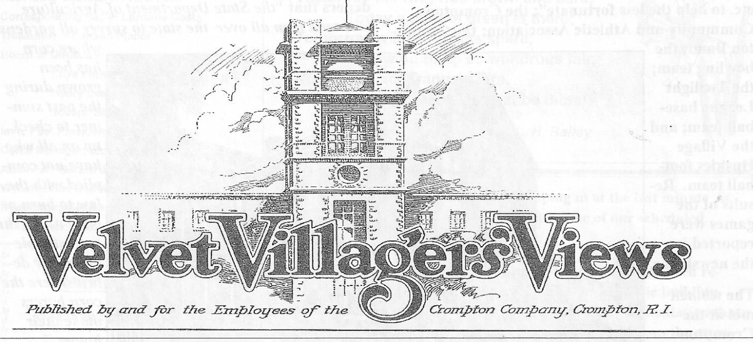
The Velvet Villager’s Views was the monthly newspaper of the Crompton Company and it ran from January 1925 to February 1932. In a subtle way it helped to unify the employees with ties that in many cases have outlasted the existence of the company. They came from diverse backgrounds. They were the Swedes, the English, the Ukranians, the Polish, the Irish, the Italians, the French-Canadians and others. Their family names usually identified their ancestry – Anderson, Moskalyk, McKenna, Rybka, Podgurski, Kowal, Picard, Ottaviano, Skoglund, Rosati, Krawczuk, Nieforth, Cienava, McGregor, and on and on and on. They not only worked side by side but at the end of the day went home to company-owned tenements where they raised their families in the same environment.
The newsletter, published by the employees, included ideas, concerns, life, both on and off the job, and lighthearted jokes, poems and stories. It also provided a voice for the company in relaying its expectations of how the employees should comply with the rules and regulations affecting the workplace and home life.
The “staff” consisted of an Editor, a News Editor and Reporters. Employees in various departments – submitted articles – the Cotton Mill Department, the Winding Department, the Cutting Department, the Dressing Department, the Mechanical Department, the Garage, and the Office. It took a great amount of people to manufacture the corduroys and velveteens that were shipped throughout the the world.
Some of the articles were of marriages, births, accidents and deaths; the celebration of birthdays and anniversaries; the bittersweet farewell to families that left the area; the jokes that helped lighten one’s load; and the vacations that refreshed the body. Poems, art and photographs were submitted. Sportsmen gave an account of their fishing and hunting expeditions. (The hunting of rabbits, pheasants, squirrels and foxes was often mentioned). After the hunt “game” suppers were enjoyed . Rabbit pie was mentioned several times.
As the families became better acquainted they formed or joined organizations. Among them the Old Timers Minstrel of Crompton; the Crompton Emergency Committee that appealed to readers of the VVV for “clothing, shoes, rubbers, etc. to help the less fortunate”; the Crompton Community and Athletic Association; the Crompton Band; the bowling team; and the Village Huskies football team. Results of the games were reported in the newsletter.
The company-sponsored outings were the high point of the year. One such outing was held in August 1931. Sixty-seven cars loaded with over 300 people left the Crompton Library grounds and headed for the Warwick Club. Food was consumed and games were played. Some played baseball but there were opportunities to win a prize if one was inclined to join in the fun of the egg race, the shoe race, the 100-yard dash and the 40-yard dash, the 3-legged race, and the bag race.
From time to time the Company issued rules and suggestions for accident control – and there were some accidents. In the April 1928 issue, the Cutting Department reported that, “Louis Barber was painfully injured on March 14 when a cutting guide and knife penetrated his abdomen. He was taken to R.I. Hospital where he was operated on and it will probably be several weeks before his return.”
Sometimes it was a reminder directed to those who lived in company housing. In the December 1931 issue. The Company warned the Community Gardeners that “the State Department of Agriculture will send men all over the state to survey all gardens where corn has been grown during the past summer to check up on all who have not complied with the law to burn or plow under the corn stubble and other debris where the corn borers make their homes.”
In another issue was a common sense warning to “not pack hay or any kind of animal feed in any of the company tenement rooms, since this causes fires.”
Early signs of trouble appeared in 1929. Lawrence Richmond, Treasurer, addressed the employees in a full-page notice informing them that “due to an unusually large production of all kinds of Silk Velvets and large importations of Foreign Velveteens, a condition has arisen in the goods market which necessitates a temporary curtailment in the production of Crompton Velveteens. We need to make our goods so perfect and so desirable that every buyer in the United States will insist on buying Crompton Velveteens and refuse to accept substitutes.”
The company continued its efforts to survive but in early 1932 it was evident that even the cost of publishing the newsletter was on the table. The company addressed the matter in the February 1932 issue with an article titled, “At Last We Must Leave You.” The first paragraph indicated that the reasoning behind the news was to “establish a friendly contact between our Velvet Villagers and the Crompton Company. He went on to state that it “has not been all in vain.”
Mr. Richmond acknowledged the contributions of all who were instrumental in publishing the newsletter and ended with thanking “all our readers and our many friends for their kind encouragement.” The newsletter ran for 7 years plus 2 months.
NOTE: Beginning in 1925 the company decided to locate elsewhere. By the late 1930s the cotton spinning and weaving were carried on at the Crompton-Highlands Mills in Georgia and at a plant in Virginia. The main activity locally was the bleaching, dyeing and finishing of the fabrics that were manufactured in the South.
The Great Depression and World War II also took a toll. By 1935 the company had sold most of its houses, and by 1945, its mills. Cecilia A. St. Jean

