CHRISTMAS PAST

Try to visualize, if you will, the Holiday Season of 1939. There are no malls or superhighways – the war has begun in Europe but at home we are still unaffected – the main roads into Providence are two lanes wide and road rage is a thing of the future. Traveling into the “city” is an event. Gone with the Wind, starring Clark Gable and Vivien Leigh, is playing at Loew’s State Theater (now PPAC) and Gladdings, The Boston Store, Shepard’s and the Outlet are the prominent retail stores. The Outlet, especially, is the store to visit, with its upstairs Santa and Toyland and the several animated window displays at street level that draw viewers from all over the state to gaze in awe at their splendor. And not to be missed is the Christmas-light display at Roger Williams Park, its glowing lights shining from dusk to ten o’clock nightly from Thanksgiving through New Year’s Day.

Back in West Warwick, local merchants are doing their utmost to attract customers. Sears has the only Santa and he came to town Thanksgiving weekend. Main and Washington Streets have been decorated with garlands and wreaths at the expense of the Chamber of Commerce. Christmas Carols blare from a sound system at Arctic Square and all the stores are open five nights a week through to Christmas Eve when they close at 5 PM so that employees can be at home with their families.

As ever, it is a time for children. Gifts of choice are sleds and skates and dolls and bicycles and checkers and Erector sets and chemistry sets and drawing kits. It is not yet the era of electronics and the price of toys is reasonable. Along with the toys, children receive articles of clothing to sport as holiday finery as they attend church services with their parents.

As West Warwick is a predominantly Roman Catholic community with several ethnic parishes serving the French and Italian and Polish and Portuguese and Irish, Midnight Mass is a Christmas highlight. Each church erects a manger featuring the Holy Family.

All Masses are sung in Latin, but the carols and hymns are in the native language of its ethnic group. Churches open their doors at 11 PM and it’s usually a stampede to get a “choice” seat. Though tickets have been sold there are no reserved seats. At about eleven-thirty the organist begins playing carols. Near midnight all lights are extinguished and a hush envelops the congregation. Promptly on the stroke of twelve, lights come ablaze and the organist loudly musically proclaims the Advent of the Lord. For the French Minuit Chretien, L’Heure Solennelle, intones the solemn arrival of the new-born Christ into our midst. Services last about an hour and are followed by the boisterous exchanging of “Best Wishes” by congregants as they trek homeward, most often through falling snow which adds to the glamour of the occasion.

For the French the real secular celebrating began when they got home. It was called “Le Réveillon” or “The Awakening.” Featured foods of the season – always of ethnic origin – were served. And the get-together was an extended family affair, including grandparents, aunts, uncles and cousins and perhaps close family friends for good measure. French meat pies (tourtières) were the “pièce de résistance but other foods abounded. There would be a “toast” to the holiday and the festivities would usually end with the distribution of gifts – to the great delight of the young and the young-at-heart.

For those who attended Mass at Midnight, Christmas Day was almost an anti-climax. It was usually a day of visiting relatives who lived nearby; and for the young to frolic in newly-fallen snow or to take advantage of the frozen ponds on their new ice skates. For all, it was a time of relaxation and simple pleasures in the midst of the security of family.

This article was written by Gerald W. Archambault for the December 2005 issue of our newsletter, The Pawtuxet Valley Historian.

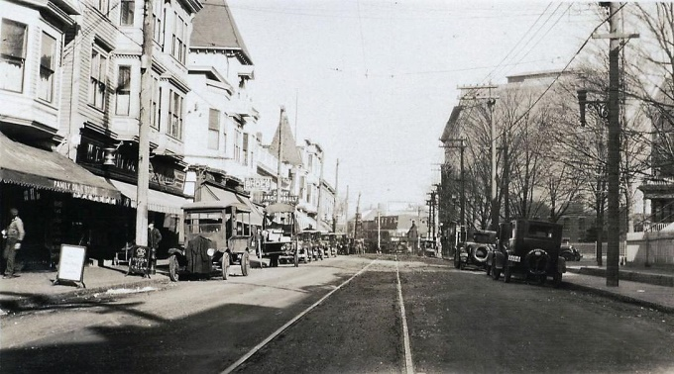

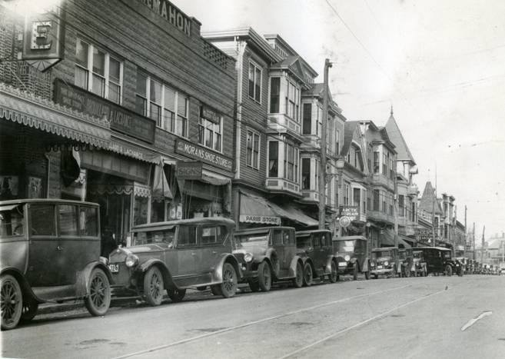
Arctic in the 1930s
1874 - 1938

